REDLINE
Medical Supplies & Equipment Trading
ريد لاين للتجارة في المستلزمات والمعدات الطبية

Basic Database Configuration
إعداد قاعدة البيانات الأساسية
Initial Odoo setup guide - company, localization, structure, users, settings and procedures

Project | Odoo ERP Implementation - Graduation Project (simulation)
Document code | RL-BDC-001
Version | 1.0 (final)
Preparation date | 25 October 2026
Business reporting period | 1 May 2026 – 30 September 2026
Target platform | Odoo 19.0 (Enterprise edition assumed)
Prepared by | Mohamed Mahmoud Abdel Bary, Mohamed Essam El-Din Youssef, Ahmed Mahmoud Mohamed, Fathy Adel Fathy, Omnia Haitham
Currency | EGP - Egyptian Pound
Disclaimer: all companies, partners, bank details and transactions in this project are fictional or illustrative simulation data. Nothing in this document claims that the configuration has been installed, imported or tested on a live Odoo server.

Contents
1 | Purpose, scope and status
2 | Version, edition and feature classes
3 | Company profile and legal-entity assumptions
4 | Language, localization and formats
5 | Branch representation and warehouse hierarchy
6 | Users, roles and access (placeholders)
7 | Module settings: Sales, Purchase, Inventory, Accounting
8 | Product tracking and expiry configuration
9 | Taxes, payment terms, journals and reporting
10 | Training outline
11 | Backup, import and data-validation procedures
12 | Go-live checklist and limitations
Section numbers are used for cross-references throughout the document set (e.g. 'SSD 4.2' = Solution Design Document, section 4.2).

1. Purpose, scope and status
This document specifies how a new Odoo database for RedLine Medical Supplies & Equipment Trading is to be initialised. It is a configuration specification and runbook for the project team. It has not been executed on a live Odoo server; menu paths and technical field names must be re-verified in the installed version.
Security note. No real passwords, API keys, bank credentials or personal data appear in this document. All user accounts are role-based placeholders; credentials are to be generated at deployment and stored in a password manager.

2. Version, edition and feature classes
Item | Decision
Odoo version | Odoo 19.0 (stable at the time of writing). Version 'Odoo 20' could not be verified; if a newer version is used the field names and paths below must be re-checked.
Edition | Enterprise assumed for Quality, Barcode, Studio, bank reconciliation UI and branch management; Community fallback documented in the SSD (SSD 5.3).
Hosting | To be decided (Odoo Online, Odoo.sh or on-premise). Production + staging databases recommended.
Database name (proposed) | redline_prod / redline_staging

Class | Meaning in this project
Standard | Available in the standard apps without extra modules (Sales, Purchase, Inventory, Accounting, Contacts)
Standard (configuration) | Standard feature that needs settings or master data
Enterprise / optional app | Requires Odoo Enterprise or an additional app (Quality, Barcode, Studio)
Customization (proposed) | Custom field/module or third-party add-on; not built or tested
Manual procedure | Process step performed by people outside the software

3. Company profile and legal-entity assumptions
Item | Detail
Company name | RedLine Medical Supplies & Equipment Trading
Arabic name | ريد لاين للتجارة في المستلزمات والمعدات الطبية
Street | 45 Makram Ebeid St
City / state | Nasr City, Cairo
Country | Egypt
Email | info@redlinemedical.com.eg
Currency | EGP
Timezone | Africa/Cairo (UTC+02:00/+03:00 depending on DST rules in force)
Tax ID / commercial register | Placeholders - to be supplied by the company
Legal entity | Single legal company; branches are not separate legal companies
Fiscal year | 1 January - 31 December
Opening cut-over date | 2026-05-01 (simulated)

4. Language, localization and formats
Setting | Value | Notes
Languages installed | English (US) and Arabic (Syria/Arabic generic as available) | Install Arabic; users choose language in preferences
Date format | DD/MM/YYYY | Per language record
Time format | 24h
Currency | EGP, 2 decimals, symbol after amount | Rounding 0.01
Number format | 1,234.56 | Thousands ',' decimal '.'
Week start | Sunday | Egyptian weekend Friday-Saturday
Arabic printing | RTL support on QWeb reports; Arabic fonts embedded (e.g. Noto Naskh Arabic) | Test every printed document in Arabic
Fiscal localization | Generic company-specific chart (loaded from CSV) | Verify whether an Egyptian localization package exists and its tax report

5. Branch representation and warehouse hierarchy
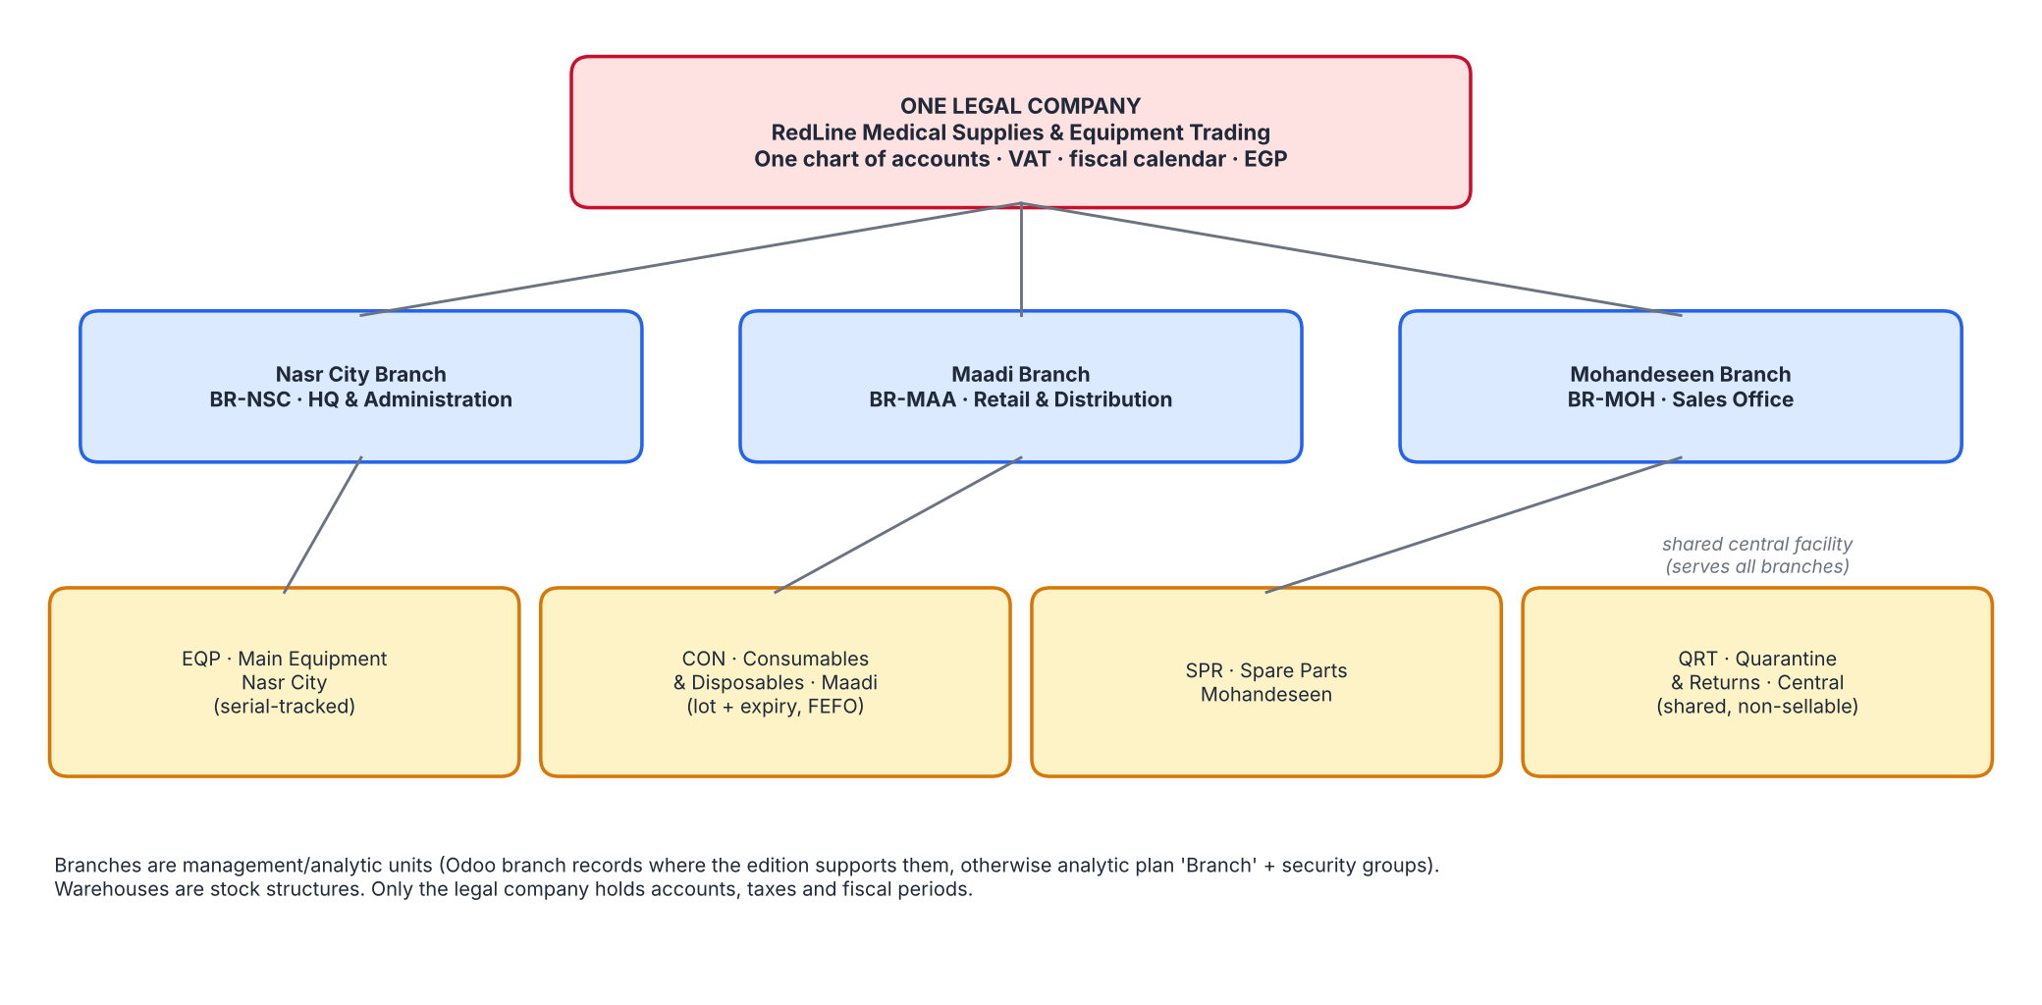
Figure 1 - Branches and warehouses in a single-company model
Branches. If the edition supports branch records (child companies of the parent), create three branches under the parent company; they share the parent's chart of accounts, taxes and currency, while journals and reporting can be branch-specific. Where branch records are unavailable, use the analytic plan 'Branch' (BR-NSC, BR-MAA, BR-MOH) on sales, purchase and expense lines, plus security groups. Limitations are discussed in SSD 5.3.
Warehouse | Short name | Reception | Delivery | Stock location | Special locations
Main Equipment Warehouse (Nasr City) | EQP | 2 steps | 2 steps | EQP/Stock | EQP/Input, EQP/Output
Medical Consumables & Disposables Warehouse (Maadi) | CON | 2 steps | 2 steps | CON/Stock | CON/Input, CON/Output; removal FEFO
Spare Parts Warehouse (Mohandeseen) | SPR | 1 step | 1 step | SPR/Stock | -
Quarantine & Returns Warehouse (Central) | QRT | 1 step | 1 step | QRT/Quarantine | Not sellable; excluded from reservations

Create warehouses through Inventory > Configuration > Warehouses so that Odoo generates operation types and routes. Mark QRT as a non-sellable location by excluding it from the sales warehouse selection and by keeping it out of the company's reservable locations (scrap/return location settings).

6. Users, roles and access (placeholders)
User (placeholder) | Role / group | Branch scope | Key access | Credential handling
admin.odoo (IT Administrator) | Administration / Settings | All | Settings, users, technical menus | Generated at deployment; MFA recommended
gm.redline | General Manager (read all, approve) | All | Dashboards, approvals | Placeholder
fin.manager | Accounting / Adviser | All | Full accounting, period lock | Placeholder
ar.officer / ap.officer | Accounting / Billing | All | Invoices, bills, payments (no lock dates) | Placeholder
sales.mgr | Sales / Administrator | All | Quotations, pricelists, approvals | Placeholder
sales.nsc / sales.moh | Sales / User: Own documents | BR-NSC / BR-MOH | Quotations and orders | Placeholder
retail.maadi | Sales / User + Point of sale (optional) | BR-MAA | Retail orders; cash safe CSH2 receipts | Placeholder
purch.mgr / purch.officer | Purchase / Administrator and User | All | RFQs, POs; approval by manager | Placeholder
wh.mgr | Inventory / Administrator | All warehouses | All stock operations, adjustments | Placeholder
wh.eqp / wh.con / wh.spr | Inventory / User | Own warehouse | Receipts, deliveries, transfers | Placeholder
quality.officer | Quality / User + Inventory / User | QRT + all | Quality checks, quarantine, scrap | Placeholder
service.mgr | Inventory / User (read) + custom Service | BR-MOH | Warranty, spare-part issues | Placeholder

Segregation of duties. Creating a vendor, approving a bill and releasing a payment must be performed by different users (SEC-004). Standard Odoo groups give coarse control; record rules per branch/warehouse (SEC-002) and a multi-level approval chain are proposed customizations/Studio configuration to be verified.

7. Module settings

7.1 Sales
- Quotation templates, pricelists with fixed discounts per customer (SAL-006); VAT 14% default on products.
- Customer credit limit: enable the credit-limit warning on sales orders; hard block is a proposed customization (CON-004).
- Approvals: quotation approval above EGP 500,000 (SAL-002, proposed - Studio or custom rule).
- Invoicing policy: delivered quantities for equipment and consumables.
- Analytic account 'Branch' assigned from the salesperson/branch.

7.1a CRM
- Install the CRM app; create sales teams Nasr City, Maadi and Mohandeseen with placeholder salespeople (CRM-004).
- Stages: New, Qualified, Quotation Sent, Negotiation, Won, Lost with probabilities 10/25/50/75/100/0 (CRM-002); lost reasons list (CRM-007).
- Activities types: call, visit, demo; lead sources list (CRM-001, CRM-005).
- Enable quotations from opportunities; tender tags (CRM-003, CRM-008).

7.2 Purchase
- Order approval: double validation above EGP 250,000 (PUR-002).
- Billing control: on received quantities (three-way match).
- Vendor lead times and reordering rules per product (INV-012).
- Vendor price lists hold supplier product code and unit cost.

7.3 Inventory
- Enable: Storage Locations, Multi-Step Routes, Lots & Serial Numbers, Expiration Dates, Display Lots & Serial Numbers on Delivery Slips, Packages (optional), Barcode (optional).
- Removal strategy: FEFO for category 'Medical Consumables'; FIFO for others.
- Negative stock disabled; reservation from specific lots enabled.
- Delivery in 2 steps (Pick, Ship) for EQP and CON; reception in 2 steps with quality control point on receipts (Quality - Enterprise).
- Scrap reasons: 'Expired' -> account 540200, 'Damaged' -> account 540300 (account mapping on the scrap location or by journal-entry rule - verify).

7.4 Accounting
- Load chart of accounts (101 accounts) and journals from the import package; set account groups for statements.
- Automated inventory valuation, FIFO, Anglo-Saxon accounting (stock interim accounts 130600 / 210500).
- Enable analytic accounting with plan 'Branch'; lock dates at month-end; fiscal year Jan-Dec.
- Payment methods: manual, cheque; bank journals CIB1 and NBE1; cash journals CSH1-CSH3.

8. Product tracking and expiry configuration
Product group | Tracking | Expiry | Removal | Examples
Equipment | By unique serial number | No (no business reason) | FIFO | EQ-MRI-001, EQ-MON-001
Consumables with shelf life | By lots | Yes: expiration, alert (60 days), removal dates | FEFO | CN-SYR-001, CN-GLV-001, CN-KIT-001
Consumables without expiry | By lots | No | FIFO | CN-TUB-001 (silicone tubing)
Spare parts | None (batteries/sensors/gaskets) or lots (filters) | No | FIFO | SP-BAT-001, SP-FIL-001

Expiry rules: lots with fewer than 60 days remaining are excluded from customer picking and isolated monthly in the Quarantine warehouse; expired lots are scrapped to account 540200.

9. Taxes, payment terms, journals and reporting
Tax | Rate | Account | Use
Sales VAT 14% | 14% | 220100 | Customer invoices
Purchase VAT 14% | 14% | 140300 | Vendor bills

The 14% rate and full recoverability are assumptions for the simulation; a qualified Egyptian tax advisor must confirm rates, exemptions for specific medical items, withholding tax and e-invoicing obligations before go-live.
Payment term | Definition
Immediate | Due on invoice date
15 days | Net 15
30 days | Net 30
45 days | Net 45
60 days | Net 60

Journal | Name | Type | Default account
INV | Customer Invoices | Sales | 410100 (per product category)
BILL | Vendor Bills | Purchase | Per product category / expense account
STJ | Inventory Valuation | General | Stock valuation accounts (130100/130200/130300)
MISC | Miscellaneous Operations | General | —
OPEN | Opening Balances | General | 310200
CIB1 | CIB Bank | Bank | 110201
NBE1 | NBE Bank | Bank | 110202
CSH1 | Cash Safe — Nasr City | Cash | 110101
CSH2 | Cash Safe — Maadi | Cash | 110102
CSH3 | Cash Safe — Mohandeseen | Cash | 110103
EXCH | Exchange Difference | General | 450200 / 710200

Standard reports configured: Balance Sheet, Profit & Loss (branch filter), Trial Balance, Partner Ledger, Aged Receivable/Payable, Tax report, Inventory Valuation, Stock Traceability, Expiry report. See Organization_and_Accounting_Charts.xlsx, sheet 'Financial Reporting Structure'.

10. Training outline
Module | Audience | Duration | Hands-on exercise
Odoo navigation, Arabic/English | All users | 2 h | Switch language; print a quotation in Arabic
Sales and credit control | Sales team | 4 h | Quote -> order -> delivery -> invoice; credit warning
Purchase and replenishment | Procurement | 3 h | Run scheduler; PO approval; bill matching
Warehouse, lots, serials, FEFO | Warehouse staff | 5 h | Receive lots with expiry; serial equipment; FEFO delivery; transfer
Quality and quarantine | Quality, Warehouse | 3 h | Failed inspection; return to vendor; scrap expired lot
Accounting and period close | Finance | 6 h | Payments, reconciliation, valuation to GL, lock dates

11. Backup, import and data-validation procedures

11.1 Backup
- Daily automated database dump + filestore copy (retention: 7 daily, 4 weekly, 6 monthly) to storage outside the application server.
- Weekly restore test to the staging database; compare record counts (partners, products, journal entries).
- Take an extra full backup before each import batch and before period close.

11.2 Import order and data validation
- Settings and accounts: company, accounts, journals, taxes, payment terms.
- Warehouses and locations; product categories; products; partners; lots and serials; opening stock; reordering rules (see Import_Package/README.md).
- After each batch compare imported counts with the CSV (Chart of accounts 101, products 24, customers 13, vendors 6, serials 186).
- Reconcile opening stock quantity and value (EGP 24,170,200.00) to the opening-balance workbook; reclassify the stock-adjustment counter-account to 310200.
- Run trial balance and valuation report; investigate any difference before go-live.

12. Go-live checklist and limitations
- Confirm Odoo version/edition and re-verify all menu paths and field names.
- Accountant review of chart of accounts, VAT, withholding tax, e-invoicing.
- Verify branch management availability and decide the fallback model.
- Test Arabic RTL printing for every customer-facing document.
- Execute UAT on a staging database (UATD workbook); today most scenarios are 'simulated review' only.
- Replace placeholder tax IDs, bank accounts and user credentials with real values through secure channels.

